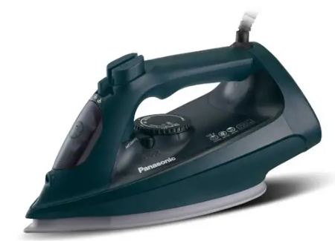
Panasonic Iron
Rs.19,000
A Panasonic electric iron is designed for fast, smooth, and efficient wrinkle removal, using advanced steam technology and durable soleplates for all types of fabrics.

Specifications
- Power: 1800W – 2600W
- Water Tank Capacity: 120 – 300 ml
- Voltage: 220–240V
- Heating Time: ~20–30 seconds (fast start models)

Key Features
- Suitable for different fabrics
- Removes stubborn wrinkles easily
- Can iron hanging clothes
- Adjustable Temperature Control

